“Hello World” on the address bar:

OR:

How to make some simple GUI mockups quickly using Javascript

In Mozilla I was able to write the following program by entering this in the address bar:

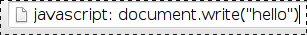

(here it is in the address bar:)

when you hit “enter” the browseer window shoukd contents shoukd be replaced by only the word “hello”

The primitive kilometer converter can also be run from the address bar (with a bit more code thats harder to read): its User Interface looks a bit like this alternate version of “hello world” from above:

